The solution presented by code number 4078 passes the spec. The solution provided is capable of sorting a Table that is NxN. The solution also sorts Tables that are NxN that are sorted. The code does not accept input that is considered not acceptable. The code was not tested on its boundaries.

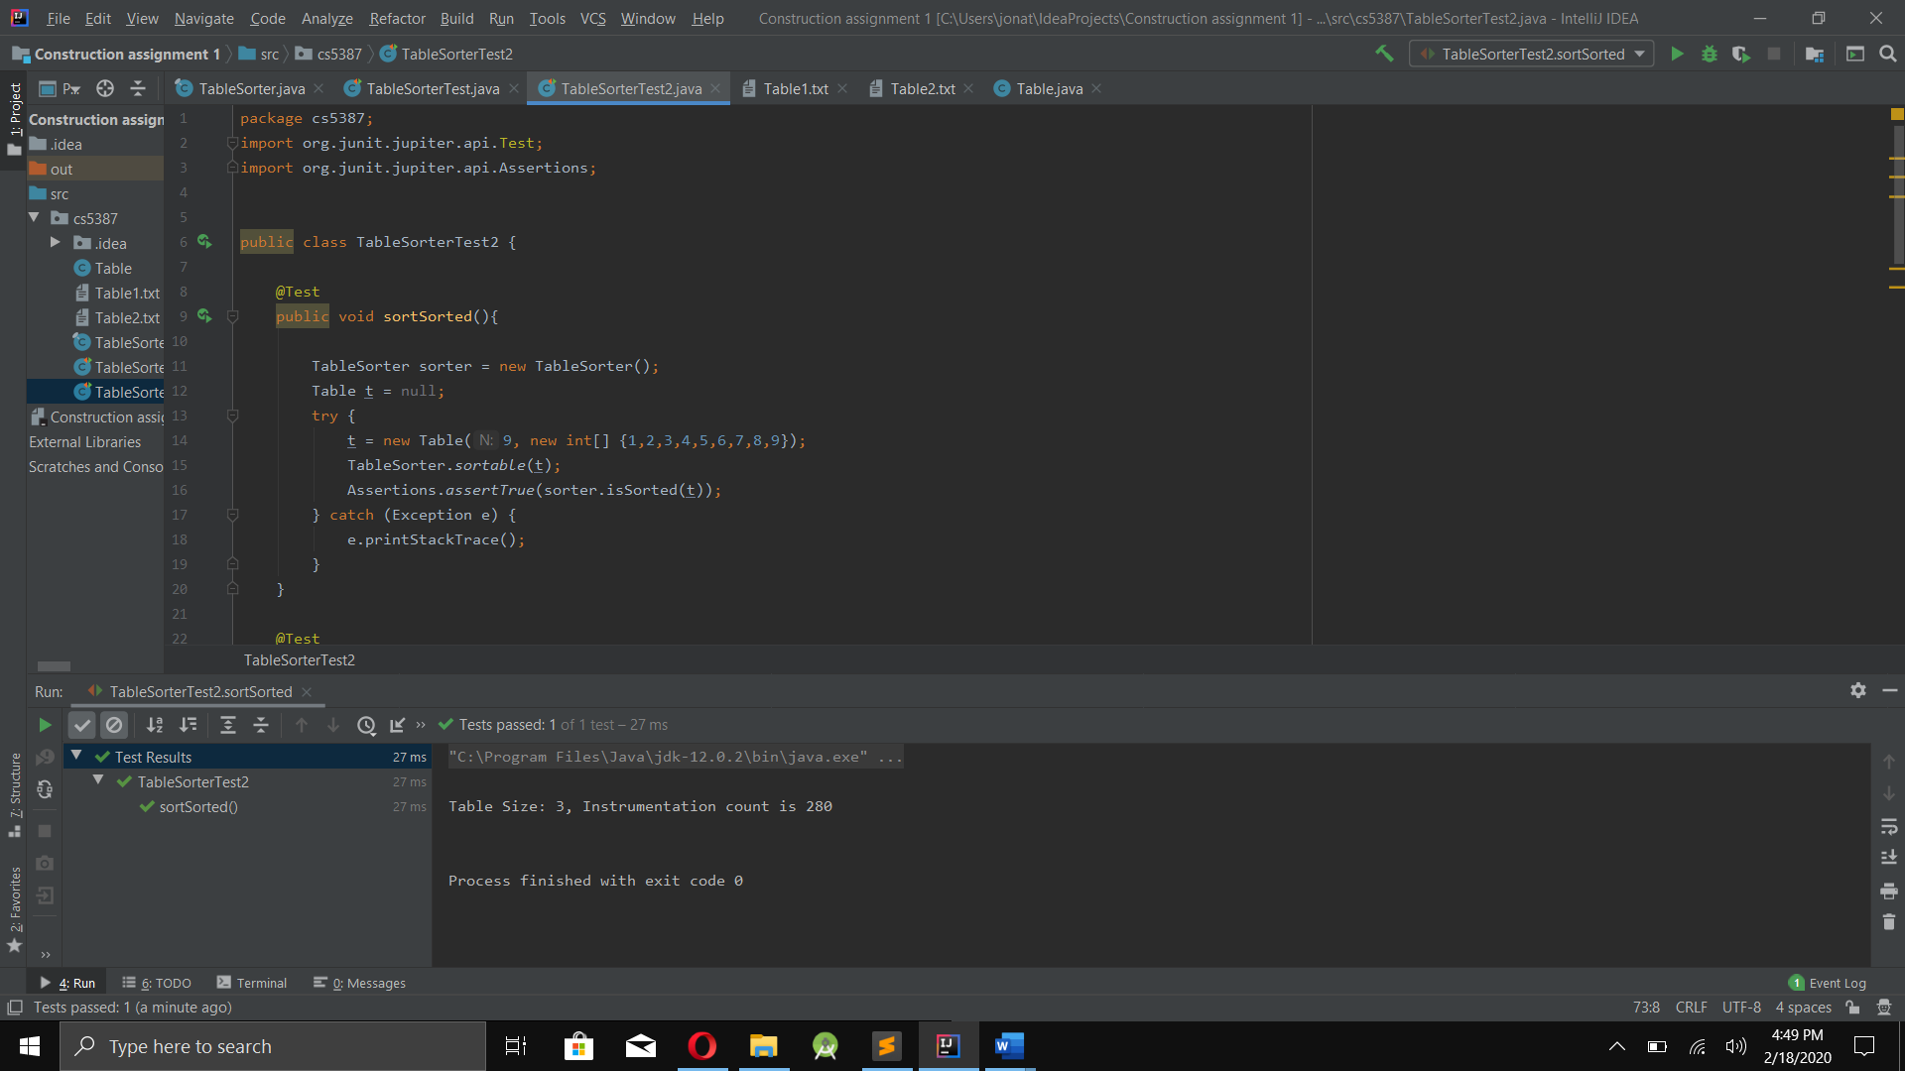Test1:

Test 2:

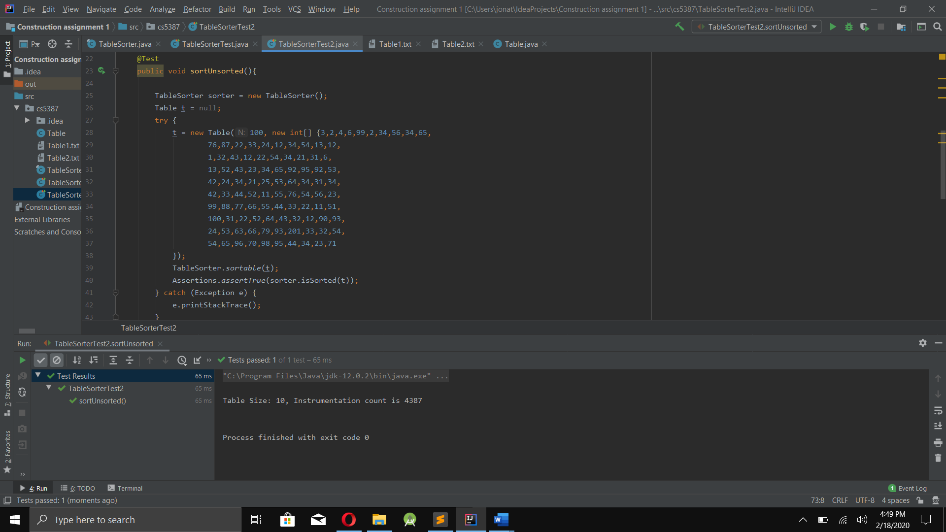

Test 3:

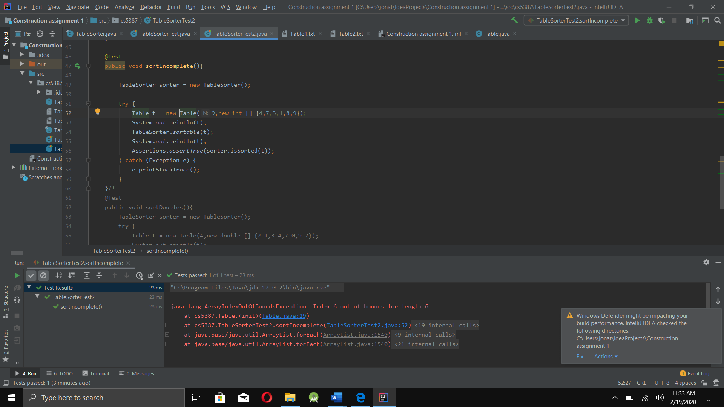

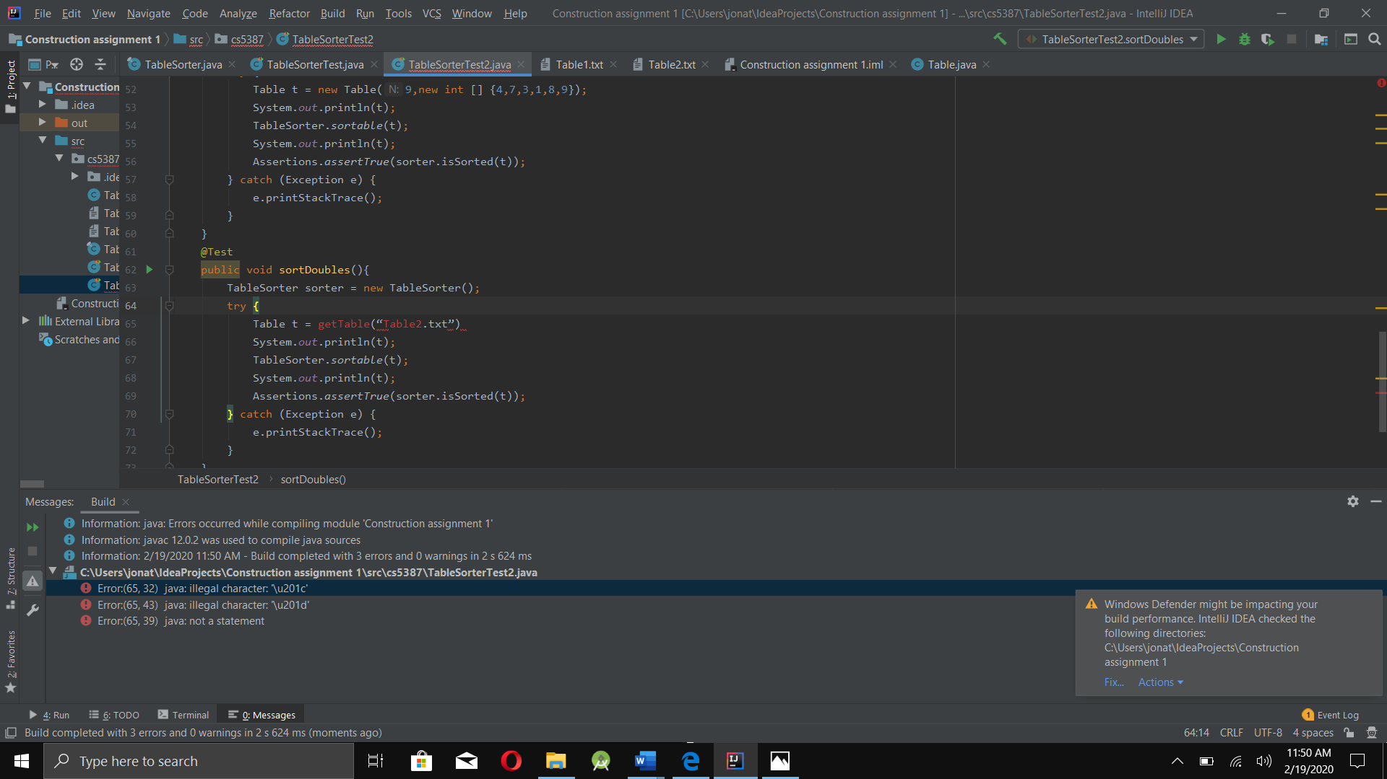Test 4: